FREE Learning From Home Webinar for Parents / Carers

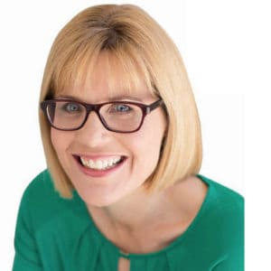
Sue Larkey is unashamedly passionate about her mission – to inspire parents and educators and teach them how to Make it a Success. Sue Larkey is uniquely positioned within the education system having taught both as a primary school teacher and a special education teacher. She is a highly qualified educator who has taught students with autism spectrum disorder in the mainstream and special schools. She combines practical experience with extensive research having completed a Masters in Special Education and currently undertaking a Doctorate in Education. Winner of Naturally Autistic 2013 International Award for Community Contribution. Sue has authored many books on autism spectrum disorders. She believes that armed with the tools of understanding and confidence, much can be achieved.

Below is a link to Sue Larkey’s FREE webinar about Learning From Home. Although this webinar is directed at students with additional needs, it provides many strategies that ALL students could benefit from.
https://elearning.suelarkey.com.au/autism-learn-at-home-during-lockdown/free-webinar-afdlg75pgagx/

Some of the topics that are covered in this webinar are:
- Strategies to make learning from home easier.
- Positioning of learning in the home.
- Strategies to assist writing tasks at home.
- Organisation of equipment for home learning.
- Scheduled break times / downtime.
- How parents / carers can support their child.
- Resources for learning from home.

